**Procedure to Configure New Proxy Settings.**

Step-1 Open Proxy Settings

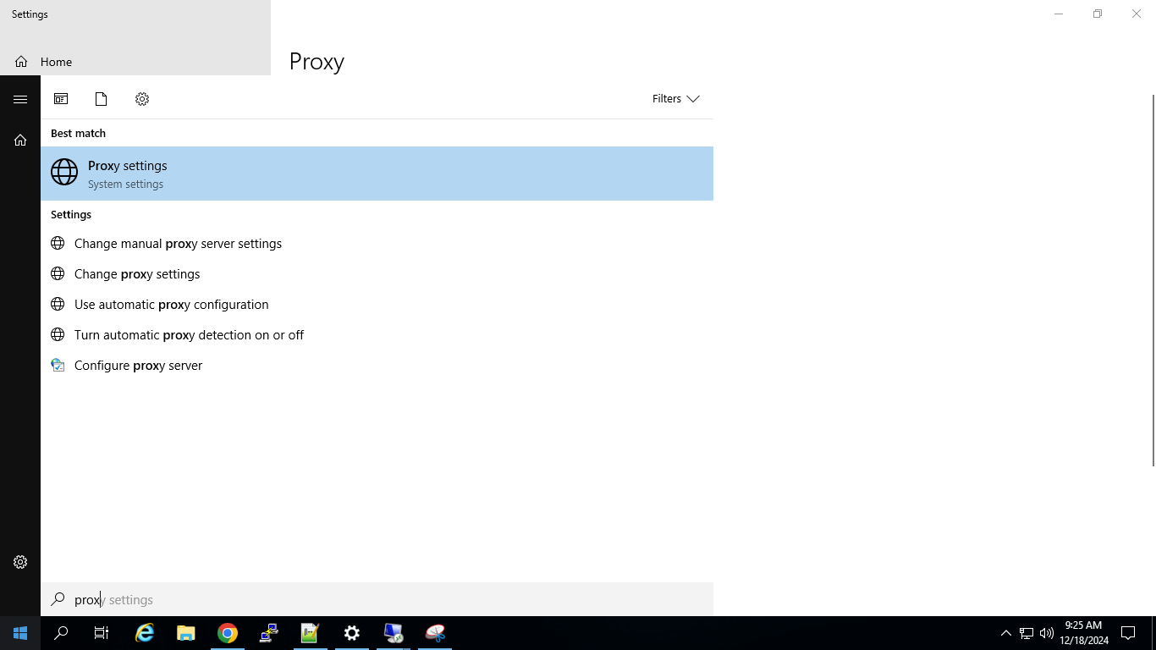

Step-2 Configure Script Address,

* Turn On Use Script Address
* Paste the below Link

https://pac.zscloud.net/wtKmWJLGzfHv/cloudproxy.pac

* and click Save

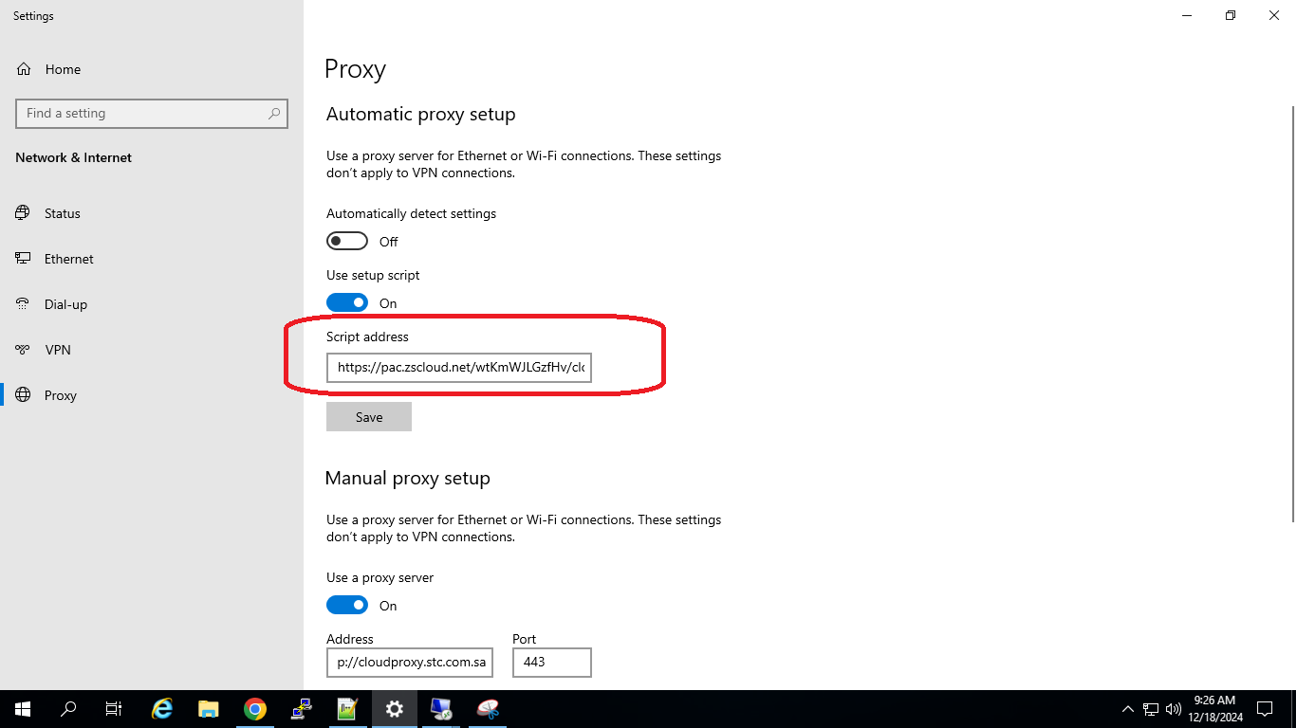

3. Configure Manual Proxy Setup

- Turn on Use a proxy Server

- Adress Field copy and paste below URL

**http://cloudproxy.stc.com.sa**

- Port field mention **443**

**-** In Use the proxy server except Address field paste below

**10.*.*.*;172.*.*.*;*.stc.com.sa;*.stc.corp;*.stcgroup.stc;*.stc.stcgroup.stc.com.sa;*.stcgroup.stc.com.sa;*.viva.stcgroup.stc.com.sa;*.stccomis.corp**

- Check Don’t use proxy Address for Local (Intranet) Address

- Click Save

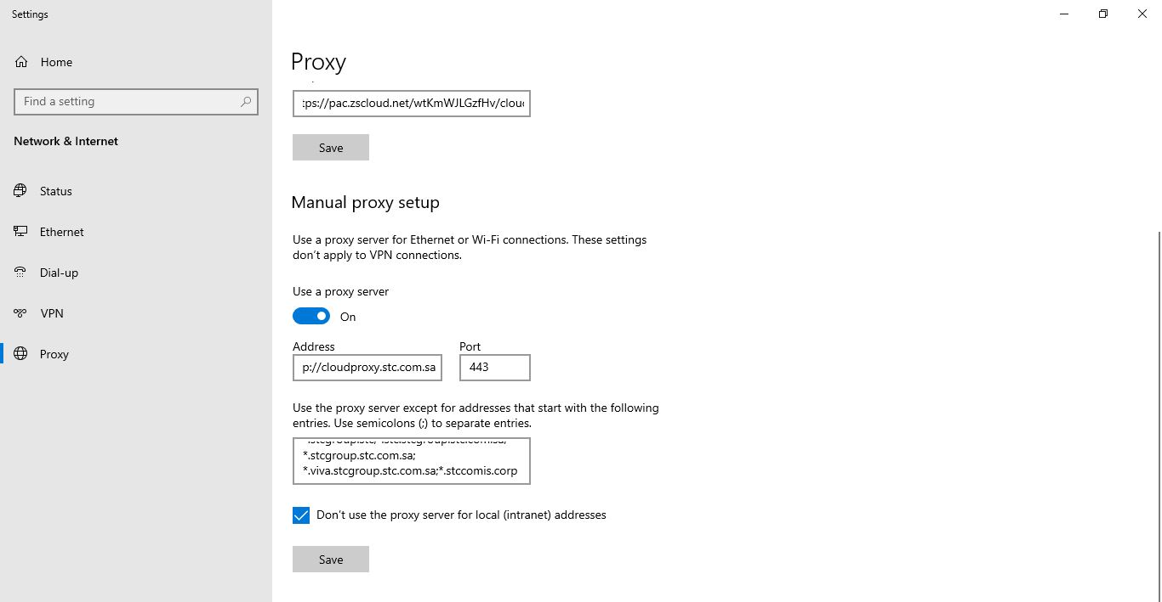

* Clear Proxy Cache

Open Powershell ( Run as Administrator) and execute below command and make sure new proxy is reflecting.

**netsh winhttp set proxy** [**http://cloudproxy.stc.com.sa:443**](http://cloudproxy.stc.com.sa:443)

**netsh winhttp show proxy**

